U.S. Radiocommunications Sector
Fact Sheet
Working Party: ITU-R WP 7B | Document No: US7B_27_017_R02
Ref: Annex 2 to the March 2024 WP7B Chairman’s Report,  Resolution 680 (WRC-23),  WRC-27 Agenda Item 1.15 | Date: 08 August 2024
Document Title: WORKING DOCUMENT TOWARDS A PRELIMINARY DRAFT NEW REPORT ITU-R SA.[LUNAR.SRS STATIONS CHAR]
Author(s)/Contributors(s):  Name: Scott Kotler  Org: Lockheed Martin Corporation  Name: Steve Baruch  Org: NWSP for Lockheed Martin Corporation  Name: Catherine Sham  Org: NASA  Name: Dennis Lee  Org: NASA (JPL) | Phone: (703) 789-3923  Email: scott.kotler@LMCO.com  Phone: (240) 476-2600  Email: sbaruch@newwavespectrum.com  Phone: (281) 483-0124  Email: catherine.c.sham@nasa.gov  Phone: (818) 205-7623  Email: dennis.k.lee@jpl.nasa.gov
Purpose/Objective: The purpose of this contribution is to further progress the working document in WP7B with updates to the operational and technical characteristics of SRS stations on the lunar surface, and SRS systems in lunar orbit communicating with systems on the lunar surface consistent with Resolves to Invite the ITU-R 1 and 2 of Resolution 680 (WRC-23).
Abstract: WRC-23 adopted Resolution 680 and WRC-27 Agenda Item 1.15 that includes studies related to SRS systems which may operate on the lunar surface, or in lunar orbit communicating with SRS systems on the lunar surface, in the following frequency ranges or portions thereof.

- 390-406.1 MHz, 420-430 MHz and 440-450 MHz, limited to outside the SZM
- 2 400-2 690 MHz, 3 500-3 800 MHz, 5 150-5 570 MHz, 5 570-5 725 MHz, 5 775-5 925 MHz, 7 190-7 235 MHz, 8 450-8 500 MHz and 25.25-28.35 GHz
At the March 2024 meeting, WP7B made updates to the WD and included characteristics, some of which have TBD. This contribution is to further progress the working document.

Radiocommunication Study Groups | 
Source: Document 7B/TEMP/7  Reference: Resolution 680 (WRC-23)  Subject: WRC-27 agenda item 1.15 | Annex 2 to  Document 7B/35-E
 | 27 March 2024
 | English only
Annex 2 to Working Party 7B Chair’s Report
WORKING DOCUMENT TOWARDS A PRELIMINARY DRAFT NEW
REPORT ITU-R SA.[LUNAR.SRS STATIONS CHAR]
Technical and operational characteristics for space research
systems in the vicinity of the Moon
(202X)
Scope
Direct communications between landers, rovers, extravehicular activity (EVA) astronauts conducting sortie missions and experiments is crucial to enable effective scientific activities and consideration of the health of the crew in the lunar environment. Considering the unique topology of the Moon’s surface, shielded zone of the Moon (SZM) considerations, unique science opportunities in radio astronomy, and remote sensing in the lunar region/surface, technical and operational characteristics are required to determine the feasibility of frequency bands to support any envisioned lunar surface network using standards-based technologies. This report describes the concept of operations for communications in the vicinity of the Moon, including on its surface and with lunar orbiting satellites, and identifies as examples certain technical and operational characteristics for the different use cases on the Moon’s surface and by lunar-orbiting systems communicating with systems on the Moon’s surface for frequency bands identified for study in Resolution 680 (WRC-23).
Keywords
EVA, landers, rovers, Moon, surface, shielded zone of the Moon
Glossary / Abbreviations
EVA Extravehicular activity
LCT Lunar communications terminal
LTV Lunar terrain vehicle
RF Radio frequency
SZM Shielded zone of the Moon
PNT Positioning, Navigation, and Timing
WLAN Wireless Local Area Network
Related ITU Recommendations and Reports
Recommendation ITU-R P.525 Calculation of free-space attenuation
Recommendation ITU-R RA.479 Protection of frequencies for radioastronomical measurements in the shielded zone of the moon

1 Introduction
The need exists to support the most efficient and effective use of spectrum resources on the surface of the moon and in the lunar orbit for short-term and long-term communications and continuous commercial and scientific operations on and around the Moon. Operations in the lunar space include communications in the vicinity of the Moon, including its surface and in the lunar orbit.

2 General overview
Administrations in all three ITU Regions have announced and are pursuing lunar missions, with remote unmanned exploration already underway, and with human visits to the Moon set to occur as early as 2026. Technological and business model development is underway, and much of this development will transcend the scientific arena and include commercial activity.
It is of utmost importance to the successful exploration and conduct of continuous operations on the Moon for there to be a reliable, understandable, usable, and flexible communications architecture in place to handle operational scenarios for a few users or multiple groups of users. The timely and effective development of this communications architecture is essential to the advancement of humankind, lunar exploration, scientific research and the innovation and investments in other potential lunar space activities.
The framework for how the substantial communications requirements for operations in lunar/cislunar space (i.e., cislunar communications relay and data services for missions on the lunar surface and in lunar orbit) and beyond will be structured is rapidly taking shape. Systems have been and are being designed to create an internet-like architecture to support lunar missions. One of these systems, the LunaNet architecture, is designed to promote maximum interoperability and to enable use by a broad range of lunar region missions and has been adopted by the Interagency Operations Advisory Group (IOAG). LunaNet will include networking services capable of communication between nodes; positioning, navigation, and timing (PNT) services for orientation and velocity determination; time synchronization and dissemination; and science services providing situational alerts and scientific measurements. Space agencies around the world are developing similar initiatives including jointly developing network architectures to lay the groundwork, through governmental investments and pathfinding missions, for maximum interoperability and to facilitate space commerce development in the years to come. Presently commercial development of lunar surface and lunar orbit communications systems in the form of public/private partnerships characterize significant aspects of space activities – from launch services to space transportation and more.
Envisioned systems are being designed to facilitate communications to and from Earth (Earth station) for lunar assets (service users in lunar orbit and on the lunar surface) through lunar orbiting relay satellites (space stations), or to facilitate communications between lunar assets. Communications links, coupled with radiometric navigation techniques to provide location, velocity, and time information to assets on the lunar surface and in lunar orbit, will also be used. The planned systems will provide real-time relay capabilities when both ends of the link (Moon and Earth) are visible.
All the communications described in this report are between or among types of space stations on the lunar surface or in lunar orbit.
Some core elements likely to be included in all systems would include:
- Lunar surface communications (notional concept of operation in Figure 1)
• Functionally similar to terrestrial mobile services topology and standards-based wireless communication topologies.
• These links also include stations near the lunar surface.
• These links are used for direct local area communications between spacesuits, experiments, habitation, other lunar assets and communication stations, landers, rovers, and extravehicular activity (EVA) supporting sortie missions and experiments. These links are crucial to enable effective scientific activities and health monitoring of the crew and equipment in the lunar environment.
• All of these lunar surface communications described in this report will use space-hardened equipment in closed systems, within a service radius and have no direct communication with Earth.
• In some cases, existing spectrum allocations in the Space Research Service or Inter-Satellite Service are used to provide direct communication with Earth and intra-lunar relay communication capabilities. Spectrum needs will determine if these existing allocations could enable implementation of needed local area point-to-multipoint network capabilities that leverage advanced wireless technologies for envisioned applications.
- Lunar surface to/from lunar-orbiting satellites
• The reference mission concepts involve scenarios where multiple exploration EVA teams are tens of kilometers from the lander/habitats and each other, resulting in the need for support from lunar-orbiting satellites to accomplish mission objectives.
• These links are similar to Earth-to-space/space-to-Earth links but use the Moon in place of the Earth.
• All of these lunar surface to/from lunar-orbiting satellite operations described in this report will occur on lunar surface and in lunar orbit, with no direct communication with Earth.
• In some cases, existing spectrum allocations in the Space Research Service (space-to-space) or Inter-Satellite Service could be used to support these links; in other cases, additional frequency bands would help to leverage existing commercial standards and equipment.

Figure 1
Notional Lunar Surface Scenario
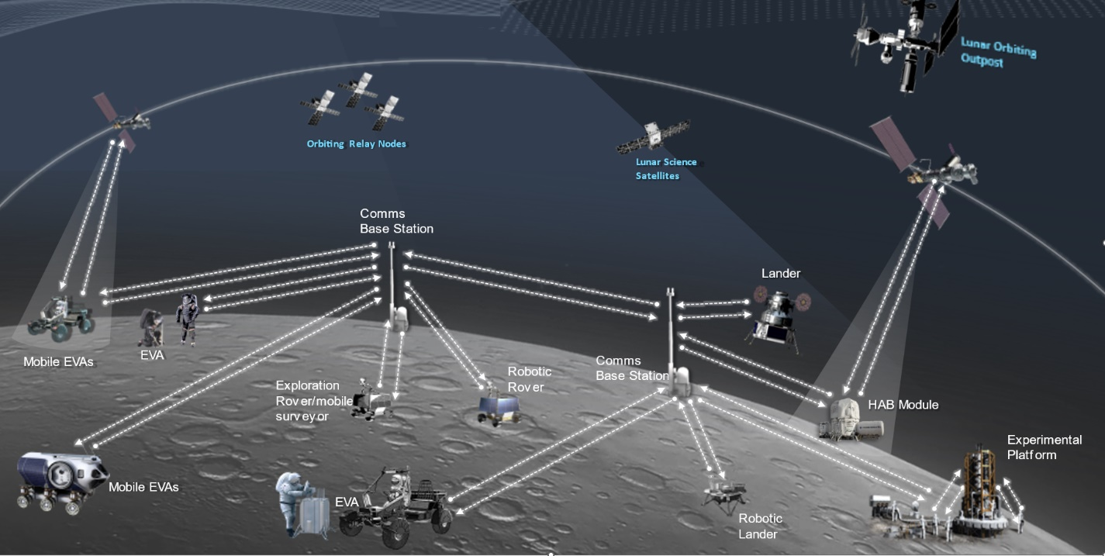

3 Concept of operations for communications in the vicinity of the Moon, including its surface and with lunar orbiting satellites

3.1 Use cases
For scientific lunar robotic and human surface missions, there are 3 categories of elements involved in the radio frequency architecture: surface elements, in-space elements and Earth-based elements. The radio links between the in-space elements and the Earth-based elements are planned to utilize spectrum that is currently allocated to space research service (space-to-Earth) (Earth-to-space) and supported by multiple networks of ground stations. In-space elements include transportation spacecraft, space platforms and relay satellites. These in-space elements around the Moon’s orbits may possess capabilities to communicate with the Earth, with another spacecraft/platform/satellite in the Moon’s orbit, and/or surface elements, depending on their individual mission objectives and whether humans are onboard. For surface elements, there are stationary and non-stationary elements with or without direct links to the Earth or an in-space element. The ubiquitous connectivity between surface elements is the means to maximize scientific return and to serve as the safety net to maintain visibility to the instrumentation and astronauts working/traveling on the Moon. Spaceflight lessons-learned confirmed a RF architecture with a minimum number of single point failures and redundancy to enable link connectivity to and between in-space and surface elements is essential, especially in the initial scientific mission roadmap for future missions. Additionally, regulatory certainty and protection are fundamental in spaceflight missions.
Various frequency ranges (low band, high band) are needed to address varying data rate requirements and distances from the base camp for different expedition crews. Reliable communications including high-definition video, clear audio, high speed bi-directional data transfer between the base camp and each element in a point-to-multipoint network topology that leverages existing commercial technologies would reduce development cycles and non-recurring costs. Additionally, higher frequency bands can support wider bandwidths for increased data throughput, local network capability for high activity areas, and point-to-point links for throughput and/or greater distances. Selecting potential frequency bands that have commonality with earth-based services leads to efficiencies in hardware and testing.
A number of user scenarios are planned for compatible local communications, for example between a surface vehicle and an orbiter, between surface vehicles, and between orbiters. Sufficient frequency separation is also required to enable compatible and simultaneous communications in the lunar space. As such, a variety of frequencies may be needed to address this type of operation.
Additional use cases requiring radio communications include space suits, handhelds, robotic landers and payloads, lunar vehicles, EVA, robotic rovers, habitation system support, manufacturing assets, and human landing systems. Such systems require spectrum access on both Lunar Surface and with Lunar Orbiting Satellites.
Table 3.1-1
Use Cases and Data Rates for communications
Users | Service Type | Typical Data Rate per User | Max Data Rate per User
EVAs | Voice/data (comm & PNT)/ video | 3 - 12 Mbps | 100 Mbps
Stationary Comm Terminal  (including Habitation) | Voice/data (comm & PNT)/video | 30 Mbps | 100 Mbps
Non-Stationary Terminals (Landers, Rover) | Voice/data (comm & PNT)/video | 3 - 16 Mbps | 100 Mbps
In-Space and Surface Elements | PNT | 500 bps | 2 kbps
Rover - LCT | Voice/data (comm & PNT)/ video | 3 Mbps | 100 Mbps
EVAs – Landers, Rover | Voice/data (comm & PNT)/video | 3 Mbps – 30 Mbps | 100 Mbps
In Space and Surface Elements Network | Voice/data (comm & PNT)/video | 30 Mbps | 100 Mbps
Surface Backhaul | Voice/data (comm & PNT)/video | 9.5 Mbps | 1 Gbps
Lunar Surface Power Grid / Elements | Data | 1 kbps | 100 kbps

Sharing studies to ensure compatibility with existing services will be based on frequencies used on both the lunar surface and on the lunar surface to lunar orbit, as shown in Table 3.1-2.
Table 3.1-2
Envisaged Concept of Operations of Spectrum Use for SRS Systems in the Lunar Environment
Frequency Band | Lunar Surface to Lunar Surface | Lunar Orbit to Lunar Surface | Lunar Surface to Lunar Orbit
390-406 MHz |  | X
406-406.1 MHz |  |  | X
420-430 MHz | X
440-450 MHz |  |  | X
2400-2480 MHz | X
2483.5-2500 MHz |  | X
2500-2690 MHz | X
3500-3800 MHz | X
5150-5570 MHz | X
5570-5725 MHz | X
5725-5855 MHz | X
5855-5925 MHz | X
[7190-7235 MHz] |  | [X]
[8450-8500 MHz] |  |  | [X]
27.5-28.35 GHz | X

3.2 Lunar surface-to-surface communications terminals
These communication terminals and links include both those on the lunar surface as well as those near the lunar surface. The links can be limited to a range up to 50 km to enhance technical compatibility and frequency re-use.
Communication technology is well-developed and widely deployed on the Earth using industry standards that could be applied to lunar communications.
Tables 3.2-1 through 3.2-3 contain the transmit and receiver characteristics for communications stations on the Lunar Surface that communicate with other stations on the Lunar Surface as described in this section.
The following frequency ranges are under consideration for communications between Lunar surface stations:
– 420-430 MHz, limited to outside the SZM;
– 2 400-2 483.5 MHz, 2 500-2 690 MHz, 3 500-3 800 MHz, 5 150-5 570 MHz, 5 570-5 725 MHz, 5 775-5 925 MHz, and 27.5-28.35 GHz.

3.2.1 EVA Communications - Operational and technical capabilities
The EVA suit provides voice/data/video service for astronauts performing activities on the lunar surface outside of the habitation module, lunar lander, or lunar rover. The EVA concept of operations involves different scenarios, including short range direct links between astronauts and longer range line-of-sight links between the astronaut and a lunar communications terminal on a lander or lunar terrain vehicle (LTV). The astronaut may also command a rover for remote exploration of the lunar surface during the EVA.
The EVA communications system is designed to provide astronauts with full audio/video capabilities at walking distances up to 2 km from the lander/LTV, with data rates up to 12 Mbps for high definition video. For contingency walk-back scenarios where the astronaut must walk back to the lander or habitation module, the EVA link is required to support telemetry data and voice up to 10 km. Due to propagation loss at higher frequencies which impacts the coverage area, critical EVA communications are best suited for frequencies below 6 GHz.
Figure 2
Example of EVA Suit
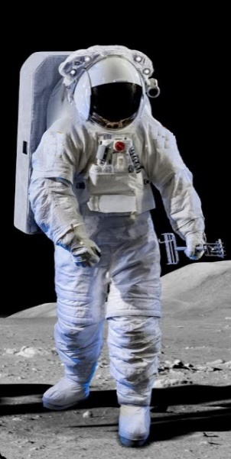
Table 3.2-3
Typical Technical Characteristics of EVA Communications links for communications on the Lunar Surface
EVA Links | Data Rate per User | Number of Links per User | Total Data Rate | Example Operating Distance | Antenna Height (AGL) | Frequency Band(s)
EVA Suit-to-Suit Comms | 100 kbps  (voice and data) | Up to 4 | 400 kbps | 200 m | 1.5-2 meters | 420-430 MHz  5855-5925 MHz
EVA WLAN  (to lander/ LTV) | 30 Mbps  (data and video) | 2 | 60 Mbps | 300 m | 1.5-2 meters | 2400-2480 MHz  5150-5835 MHz
EVA  (to lander/ LTV) | 64 kbps (voice)  34 kbps (data)  3 – 12 Mbps (video) | 1 | 12.1 Mbps | 2 km | 1.5-2 meters | 2500-2690 MHz  3500-3800 MHz  27.5-28.35 GHz
EVA  (to rover / LTV)) | 100 kbps  (commands) | 1 | 100 kbps | 2 km | 1.5-2 meters | 2500-2690 MHz  3500-3800 MHz
EVA Contingency (Walk-back) | 98 kbps⁽¹⁾  Up to 3.1 Mbps⁽²⁾ | 1 | 3.1 Mbps | 10 km | 1.5-2 meters | 420-430 MHz  2500-2690 MHz  3500-3800 MHz
⁽¹⁾ Required; voice and data only
⁽²⁾ Voice, data, and limited video depending on range and link availability

3.2.2 Lunar Communications Terminals on Stationary Platforms - Operational and technical capabilities of communications stations on the Lunar Surface
The habitation module and lunar lander are examples of stationary platforms on the lunar surface that may host a lunar communications terminal. The lunar lander is included as a stationary platform because it does not move after landing on the lunar surface, even though it moves during the ascent and descent phases. Under the envisioned con-ops, the lander will provide EVA communications to the crew members after landing including voice, data, and video. The lander may also transmit to a lunar terrain vehicle, primary for commanding. The LCT on the lander may also be used to command pressurized rovers used for remote surface exploration. Antennas for lunar surface communications on the stationary platforms such as landers or habitation modules will typically be pointed between ±10 degrees from the horizontal direction.
Table 3.2-4 shows some typical characteristics for LCTs on a stationary platform, using the lander as an example.
Figure 3
Pictorial Example of a Lunar Lander (stationary LCT)
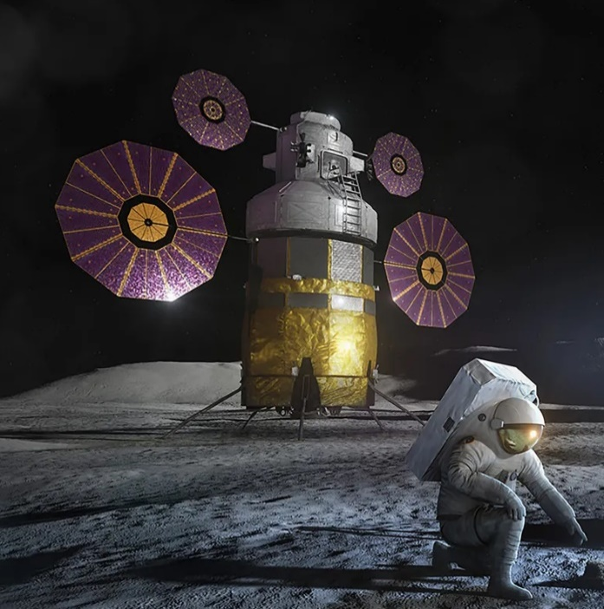
Table 3.2-4
Typical Technical Characteristics of Stationary LCTs on the Lunar Surface
LCT on Stationary Platform | Data Rate per link | Number of Links | Total Data Rate | Example Operating Distance | Antenna Height (AGL) | Frequency Band(s)
Lander  (to EVA) | 64 kbps (voice)  3 Mbps (video) | 4 | 12.3 Mbps | 10 km | 16-50 meters | 420-430 MHz  2500-2690 MHz  3500-3800 MHz  27.5-28.35 GHz
Lander WLAN  (to EVA) | 30 Mbps  (data and video) | 6 | 180 Mbps | 300 m | 6-50 meters | 2400-2480 MHz  5150-5855 MHz
Lander  (to LTV) | 100 kbps  (commands) | 1 | 100 kbps | 10 km | 16-50 meters | 2500-2690 MHz  3500-3800 MHz
Lander  (to Pressurized Rover) | 16-100 Mbps  (voice, data, and video) | 1 | 100 Mbps | 20 km | 16-50 meters | 2500-2690 MHz  3500-3800 MHz  27.5-28.35 GHz

3.2.3 Lunar Communications Terminals on Non-Stationary Platforms - Operational and technical capabilities of communications stations on the Lunar Surface
Examples of non-stationary platforms deployed on the lunar surface include the lunar terrain vehicle (LTV) and robotic rovers. The LTV (shown in Figure 4) provides transport for the crew members, while the robotic rovers carry instrument payloads for lunar exploration and scientific discovery.
Both the LTV and rovers will host lunar communication terminals. Under the envisioned con-ops, the LTV is assumed to support up to 2 crew members with full voice, data, and video capability. In addition, the LTV will host 2 high definition cameras and various scientific payloads. To support these functions, the LTV communications terminal is required to accommodate at least 16 Mbps data rate. Depending on the mission scenario, the LTV communicate with fixed surface assets (such as a lander or habitat module), EVA suits, and/or with other non-stationary platforms such as rovers. The LTV may also serve as a portable relay point between two lunar surface elements.
The rover is assumed to host a camera as well as various scientific instruments. The rover communications terminal will transmit video and data, and receive commands for remote operations. Similar to the LTV, the rover may communicate with fixed/stationary surface assets, EVA suits, and/or other non-stationary platforms. Antennas on the non-stationary platforms such as LTVs or pressurized rovers will typically be pointed ±20 degrees from the horizontal direction.
Figure 4
Pictorial Example of Lunar Terrain Vehicle (non-stationary LCT)


Table 3.2-5
Typical Technical Characteristics of Non-Stationary LCTs on the Lunar Surface
LCT on Non-Stationary Platform | Data Rate per link | Number of Links | Total Data Rate | Example Operating Distance | Antenna Height (AGL) | Frequency Band(s)
LTV/ Pressurized Rover  (to EVA suit) | 3-12 Mbps (voice, data, and video) | 2 | 6-24 Mbps | 2 km | 3 meters | 420-430 MHz  2500-2690 MHz  3500-3800 MHz  27.5-28.35 GHz
LTV / Pressurized Rover  WLAN | 30 Mbps  (data and video) | 4 | 120 Mbps | 300 m | 6 meters | 2400-2480 MHz  5150-5855 MHz
LTV/ Pressurized Rover  (to rover) | 100 kbps  (commands) | 2 | 200 kbps | 2 km | 3 meters | 2500-2690 MHz  3500-3800 MHz
LTV/ Pressurized Rover  (to stationary platform) | 16-100 Mbps  (voice, data, and video) | 1 | 16 - 100 Mbps | 10 km | 3 meters | 2500-2690 MHz  3500-3800 MHz  27.5-28.35 GHz
Rover  (to EVA suit) | 3 Mbps  (video and data) | 1 | 3 Mbps | 2 km | 1 meter | 420-430 MHz  2500-2690 MHz  3500-3800 MHz
Rover  (to LTV/ Pressurized Rover  ) | 3 Mbps  (video and data) | 2 | 6 Mbps | 2 km | 1 meter | 2500-2690 MHz  3500-3800 MHz
Rover  (to stationary platform) | 3 Mbps  (video and data) | 2 | 6 Mbps | 10 km | 1 meter | 2500-2690 MHz  3500-3800 MHz

3.2.4 Operational and technical capabilities of the Lunar Surface Backhaul
The lunar surface backhaul is envisioned as point-to-point surface wireless links connecting various sites on the Moon to the core network. These may range in data rate from 9.5 Mbps up to 1 Gbps depending on the network traffic demands. The envisioned frequency range for this application is 27.5 – 28.35 GHz.

3.2.5 Propagation considerations

The composition and electrical characteristics of the lunar atmosphere (exosphere) and lunar surface (regolith) are significantly different than the composition and electrical characteristics of the terrestrial atmosphere and terrestrial surface, and the radius of the Moon is significantly less than the radius of the Earth. As a result, there are no existing ITU-R P-series Recommendations directly applicable to propagation between communications systems on the lunar surface.
WP 3J recommends that the propagation prediction methods contained in Annex 26 to WP 3J Chair’s Report (Document 3J/67) and its attached Appendices, be used for links between systems on the lunar surface. The Longley-Rice irregular terrain model (ITM) modified for the lunar environment is the best available prediction method applicable to propagation between communication systems on the lunar surface.
An example U.S. implementation of the Irregular Lunar Model is available at https://github.com/NTIA/ILM.

3.2.6 Summary of Lunar Surface-to-Surface Transmit Characteristics

Table 3.2-6 summarizes the transmit characteristics for lunar SRS surface-to-surface communication by frequency band, rather than by application as shown in the previous tables.

Table 3.2-6
Lunar Surface-to-Surface Transmit Characteristics by Frequency Band
 | 420-430 MHz | 2400-2483.5 MHz | 2500-2690 MHz | 3500-3800 MHz | 5150-5855 MHz | 5855-5925 MHz | 27.5-28.35 GHz
Peak Antenna Gain (dBi) | 0 | 6 | 16 | 26.2 | 6 | 6 | 29.1
Max EIRP (dBW) | 2.6 | 6 | 29 | 42.3 | 6 | 13 | 39.2
Channel BW (MHz) | 2 | 20 | 10 | 100 | 40 | 40 | 200
EIRP Density dB(W/MHz) | -0.4 | -7 | 19 | 22.3 | -10 | -27 | 16.2
Antenna Polarization | Vertical  CP | Vertical  CP | Linear ±45º  CP | Linear ±45º  CP | Linear ±45º  CP | Linear ±45º  CP | Linear ±45º  CP
Antenna Pattern | TBD | TBD | TBD | TBD | TBD | TBD | TBD
Applications | EVA Suit-to-Suit, Lander/ LTV/Rover/ HAB to EVA, EVA Contingency | Lander/LTV/ Rover/HAB WLAN | Lander/LTV/ Rover/ HAB to EVA, EVA Contingency | Lander/LTV/ Rover/ HAB to EVA, EVA Contingency | Lander/LTV/ Rover/HAB WLAN | EVA Suit-to-Suit | Lander/LTV/ Rover/ HAB to EVA, backhaul surface comms
{Editor’s note: need to add deployment characteristics and antenna pattern information to Table}

3.3 Lunar surface to/from lunar-orbiting space stations

3.3.1 Operational and technical capabilities
Where EVA teams are tens of kilometers from the lander/habitats and each other, reliance exclusively on lunar-surface point-to-multipoint networks will not be sufficient, resulting in the need for support from lunar-orbiting space stations to accomplish mission objectives.
Lunar surface to/from lunar-orbiting space station links support lunar relay services including low and high-rate mission data, ranging and timing operations, and extend communications to beyond the approximate 50 km range.
The lunar PNT system will transmit navigation messages which are meant to provide users with the data needed to compute the position and time solutions, to aid various receiver tasks, and to improve positioning accuracy. The PNT message data rate is low, typically around 500 bps. The envisioned frequency range for this application is 2 483.5 – 2 500 MHz.
The following frequency ranges are under consideration for Lunar surface to/from lunar-orbiting space station communications:
– 390-406, 406-406.1 MHz (for emergency beacon; crew search and rescue), 440-450 MHz, limited to outside the SZM;
– 2 483.5-2 500 MHz (for lunar PNT), 7 190-7 235 MHz, 8 450-8 500 MHz, and 27-27.5 GHz.

3.3.2 Technical characteristics for communications between Lunar Surface and Lunar Orbit space stations
There are multiple application types to be operated within these frequency bands:
(1) Robotic landers and payloads (Stationary)
(2) Rovers (Non-stationary)
(3) Human landing systems (Stationary and Non-Stationary)
(4) Spacesuits (Non-stationary)
(5) Handheld terminals (Stationary and Non-Stationary)
(6) Habitation Systems (Stationary)
(7) Power Support (Stationary)
(8) Resource Assets (Stationary and Non-Stationary)
The transmit and receiver parameters are listed in the following tables.
{Editor’s note: The tables below are expected to be further developed based on input contributions to address these frequency bands or any others called for in Resolution 680 (WRC-23), as well as to elaborate on the application types above.}
Tables 3.3-1 through 3.3-4 contain typical transmit and receiver characteristics for stations that communicate between Lunar Orbit and Lunar Surface as described in this section.

Table 3.3-1
Lunar Surface Receiver Characteristics from Lunar Orbit
Band (MHz) | 390-406 | 2483.5-2500
Beam Type | Fixed | Fixed
Polarization | CP | CP
Receive Gain (dBi) | 0.0 | 3.0
G/T (dB/K) | ‒26.4 | ‒19.9
Min. Saturation Flux Density (dBW/m²) per 1 MHz Ref BW | ‒156.6 | ‒140.6
Max. Saturation Flux Density (dBW/m²) per 1 MHz Ref BW | ‒66.4 | ‒100.0
Antenna Height (m) | <5 | <5
Channel BW (MHz) | 2.0 | 16
Applications | 4, 5 | 1 – 8 (PNT)
Table 3.3-2
Lunar Surface Transmitter Characteristics to Lunar Orbit
Band (MHz) | 406-406.1 | 440-450
Beam Type | Fixed | Fixed
Polarization | CP | CP
Peak Gain (dBi) | 0.0 | 0.0
Max. EIRP Density (dBW/Hz) | ‒27.5 | ‒61.0
Max. EIRP (dBW) | 2.5 | 2.0
Antenna Height (m) | <5 | <5
Channel BW (MHz) | 0.05 | 2.0
Applications | 4, 5 | 4, 5

Table 3.3-3
Lunar Orbit Space Station Receiver Characteristics from Lunar Surface
Band (MHz) | 406-406.1 | 440-450
Beam Type | Fixed | Fixed
Polarization | CP | CP
Receive Gain (dBi) | 0 | 0
G/T (dB/K) | ‒26.4 | ‒26.4
Min. Saturation Flux Density (dBW/m²) per 1 MHz Ref BW | ‒156.6 | ‒156.6
Max. Saturation Flux Density (dBW/m²) per 1 MHz Ref BW | ‒66.4 | ‒66.4
Orbital Characteristics  Apolune (km)  Perilune (km) | 7000 – 11000  600 – 2700 | 7000 - 11000  600 - 2700
Channel BW (MHz) | 0.05 | 2.0
Applications | 4, 5 | 4, 5
Table 3.3-4
Lunar Orbit Space Station Transmitter Characteristics to Lunar Surface
Band (MHz) | 390-406 | 2 483.5-2 500
Beam Type | Fixed | Fixed
Polarization | CP | CP
Peak Gain (dBi) | 0 | 16
Max. EIRP Density (dBW/Hz) | ‒63 | ‒48
Max. EIRP (dBW) | 0 | 24
Orbital Characteristics  Apolune (km)  Perilune (km) | 7000 - 11000  600 - 2700 | 7000 - 11000  600 - 2700
Channel BW (MHz) | 2.0 | 16
Applications | 4, 5 | 1 – 8 (PNT)

{Editor’s note: Need to add deployment characteristics and antenna patterns, provide information on how many satellites in lunar orbit, etc.}

3.3.3 Propagation considerations

Per Working Party 3J, Recommendation ITU-R P.525 Calculation of free-space attenuation should be used for propagation calculations between lunar orbiting systems, between lunar orbiting systems and lunar surface systems, and between lunar orbiting and lunar surface systems and systems on or orbiting the Earth.

3.4 General matters

Initial surveys and testbeds of available technologies have indicated that a point-to-multipoint network based on commercial standards, such as those developed by 3GPP, can be capable of servicing the reference mission concept of operation involving many user groups over a widespread surface area with high data throughput requirements. However, considering the unique topology of the Moon’s surface, shielded zone of the Moon considerations, unique science opportunities in radio astronomy, and remote sensing in the lunar region/surface, to determine a suitable framework to support the envisioned lunar surface network using standards-based commercial equipment designed for space environment and unique operational requirements.
The Radio Regulations include provisions that are of significance to the services for the lunar space. Section V of Article 22 includes provisions on the prevention of emissions causing harmful interference to radio astronomy observations in the shielded zone of the Moon. ITU-R Recommendation RA.479-5 provides additional guidance on protection of frequencies for radioastronomical measurements in the SZM.

4 Summary
The technical and operational characteristics of SRS systems operating on the lunar surface, or SRS systems in lunar orbit communicating with SRS systems on the lunar surface, are provided for use in sharing and compatibility studies.
_______________

See David Israel et al., LunaNet: a Flexible and Extensible Lunar Exploration Communications and Navigation Infrastructure and the Inclusion of SmallSat Platforms, Presentation and Paper before Technical Session XII: Communications at Utah State University Small Satellite Conference, SSC20-XII-03, at Table 1 (2020), https://bit.ly/3LCI3n0.
IOAG Member Agencies, https://www.ioag.org/Lists/Participants/Agencies.aspx.

